
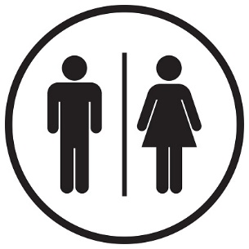





Abel and Lily

Joe Slovo
Tudhope Avenue

YOUR Taxi FARE IS
R15

R15 Total

